William Nichols Reference

Shell Canada Limited
400 - 4th Avenue. S.W. P.O. Box 100, Station M Calgary, Alberta T2f' 2H5 TEL (403)691-3111
December 17, 1998
TO WHOM IT MAY CONCERN:
It is my pleasure to provide William Nichols with a reference.
We chose William Nichols to provide deep, sour production engineering services for our Central Alberta Foothills team because we felt he would add some new ideas and a new perspective to our team. We were glad we did. William brought some new ideas for production optimization. He also showed good business sense and a thorough understanding of the petroleum industry.
William was one of two production engineers on the team, which were responsible for over 250 mmcfd from the Burnt Timber, Limestone, Clearwater and Ram fields. He was also assigned to support the Caroline Team. In this role William was responsible for designing deep, sour gas completions and workovers, optimizing existing production and day to day production engineering.
William Nichols is an accomplished production engineer and I recommend him highly.
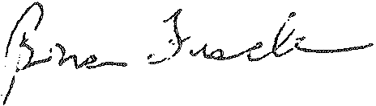
Brian Fischer
Exploration and Development Manager Central Foothills

